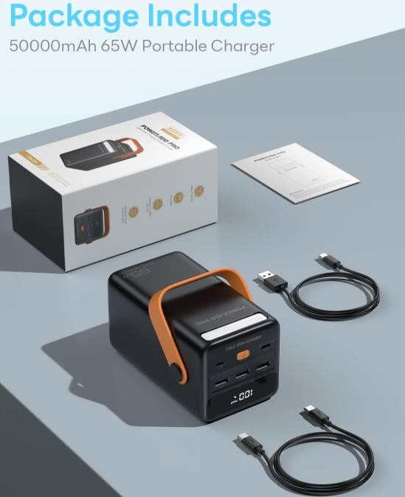
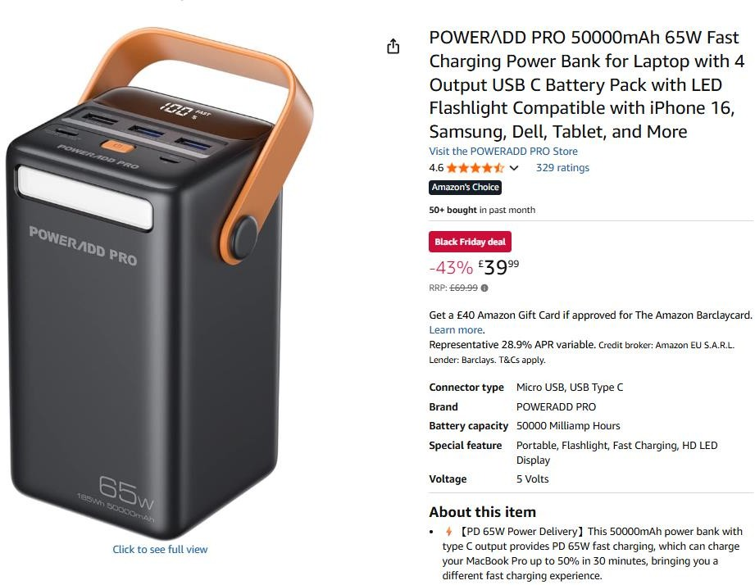

1,987pcs x POWERADD Pro 50,000mAh 65W Fast Charging Power Bank for Laptop with 4 Output USB C Battery Pack with LED Flashlight…….Originally Selling on amazon for £69.99 Cost £14.50

